An artist statement explains the thinking behind your work. It tells viewers what you made, how you made it, and why you made it. By explaining your work, you allow viewers to understand the meaning and purpose behind your work. Write about what you made, how you made it, and why you made your piece creating three well developed paragraphs
Name: Click here to enter text.
Course / Mod: Click here to enter text.
Title of Work: Click here to enter text.
Media & Size: Click here to enter text.
Image of work

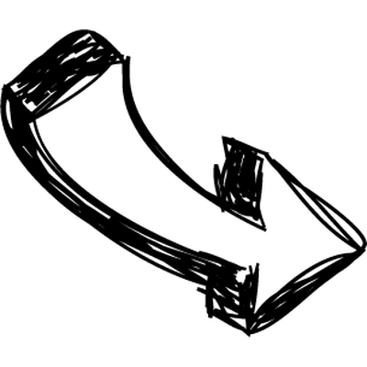
How?
The Elements, Principles and Media used. How are the art elements and principle of design used or arranged? How was the work made? What materials and techniques were used?

What?
The Subject – Describe it…What is happening in the work? What is the work about? Is it based on observation or imagination? Does it have any hidden meanings?

Click here to enter text.
Click here to enter text.

Why?
The Intent. What is the purpose or meaning of the work? Is the meaning or message personal, political, emotional, or social? How does the work affect you or make you feel?

Click here to enter text.

