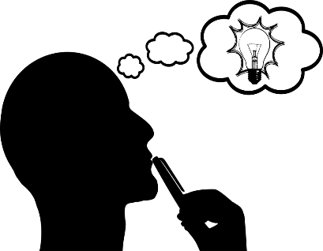
Image of work
An artist statement explains the thinking behind your work. It tells viewers what you made, how you made it, and why you made it. By explaining your work, you allow viewers to understand the meaning and purpose behind your work. Answer the questions below in paragraph form on page two.
Name: Click here to enter text.
Course / Mod: Click here to enter text.
Title of Work: Click here to enter text.
Media & Size: Click here to enter text.

Describe your piece. What does it look like? What media did you use to create it?
What or who inspired you to make this piece?
Did you have any difficulties creating this pieces? If so, what happened and what did you do to overcome them?
Does this piece relate to a broader theme, have a message, and or a personal connection? How have you expressed your persona voice?
What did you do well and what could you have done better? How will this influence future pieces?
What did you learn from planning and creating this pieces?

Click here to enter text.

